**Open Wireshark and Start Capturing:**

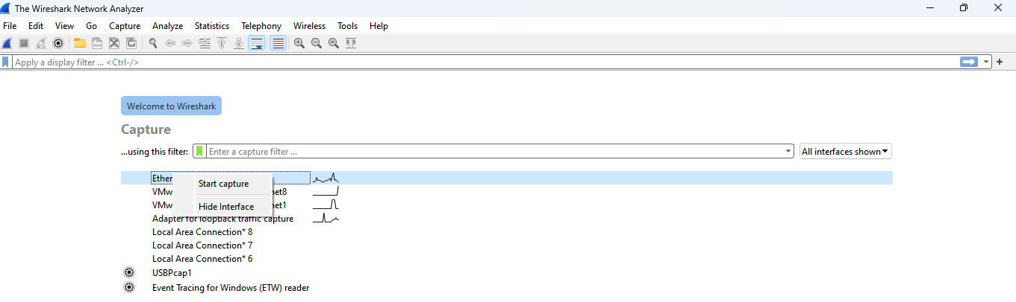

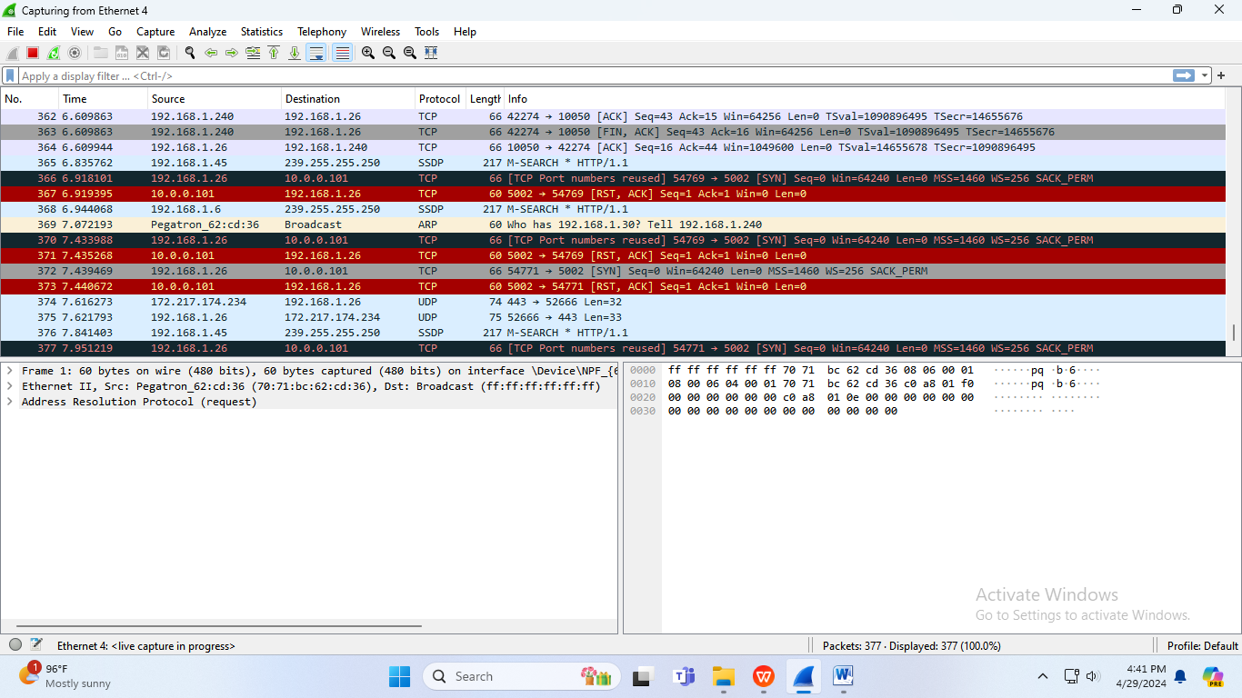

**Analyze the captured packets to extract relevant information and identify**

**potential security issues:**

**IPV4:**

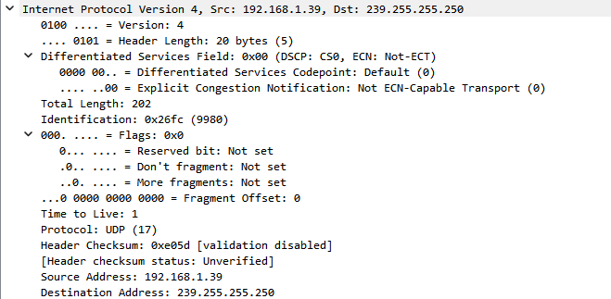

**UDP:**

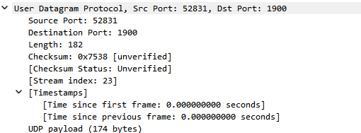

**SSDP:**

